Demo script
v1.0 - 14th August 2014

How to launch the demo:

Option1 - Recommended - From a local copy
(The latest version also be downloaded from the server: http://work.uxconsult.com/cdng/140818-files)
Expand the files into a local directory and click on start.html

Option 2 - From the server
http://work.uxconsult.com/cdng/140818-demo

Inputting time
To launch from the page ‘Home’ in the prototype

- Create a new time entry
  - Click on Add time

  - Select the time using the Time picker and choose 2:30
  - Place the cursor in the field ‘Matter.
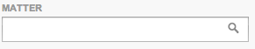
  - The menu drops down with the recent items
  - Type: Co
The search activates and presents the relevant search results
  - Type: Con
  - Type: Cont
NOTE: Type slowly enough so that the prototype recognises the input
  - Select 1231.Contract negotiation
The client has been populated using the Matter selected
  - Focus on ‘Phase’
  - Select 0000.Preparation
The task is automatically populated as there is a single Task associated to the phase
  - In the narrative type: Telephone call
  - Save
A new entry is created
The global tracking data is updated at the bottom of the page
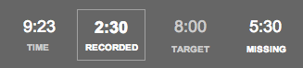
- Create a Quick ID Time entry (Entry on the fly using the counter)
  - Start the Timer on New entry
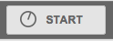
  - In Quick ID, type in ‘Anything’
  - In the narrative type: Call
  - Save
A new entry is created
The global tracking data is updated
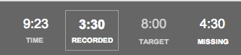
- Create an entry using the worklist
  - Expand the worklist
  - On the worklist item ‘1154. Laval Hebert’ click START to initiate the counter
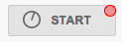
  - In the narrative type in ‘Review contact’
  - Save.
  - The global tracking data is updated. The previous timer set is automatically stopped.

Inputting time
To launch from the page ‘Entries management’ in the prototype

Note: The page may take a few seconds to load as there is a lot of script.

- The timesheet is presented by default. Entries are presented by ‘Event time’
Switch to ‘Sort my matter’
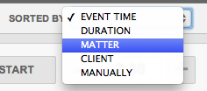
- Entries are now structured by Matters.
- Reveal ‘Found time’ to identify possible missed time entries (recovered from TimeFinder). Switch ‘Found Time’ to ‘on’
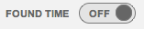
- Recovered time entries are presented in line in the page, in blue
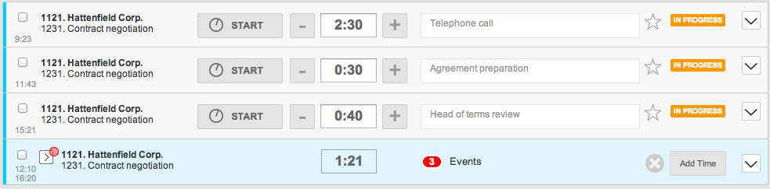
- Recovered time is presented in the form of ‘clusters’ which can be expanded further.
Click on ‘Hattenfield Corp.” to reveal the detail of the events.
- Best match events are presented by default.
- 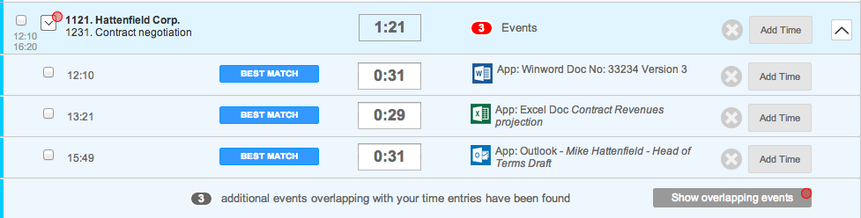

Advanced Time Finder
Advanced Time finder is an optional view which allows users to focus on the missing time only.
Please refresh the prototype page in the browser or click on ‘Entries management’ so that the variables are reset.

- Launch TimeFinder at the bottom of the screen by clicking on ‘Show timefinder’
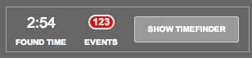
- The Timesheet collapses and Time Finder events are presented.
By default the system presents the ‘Best Matches’ organised by ‘Matters’
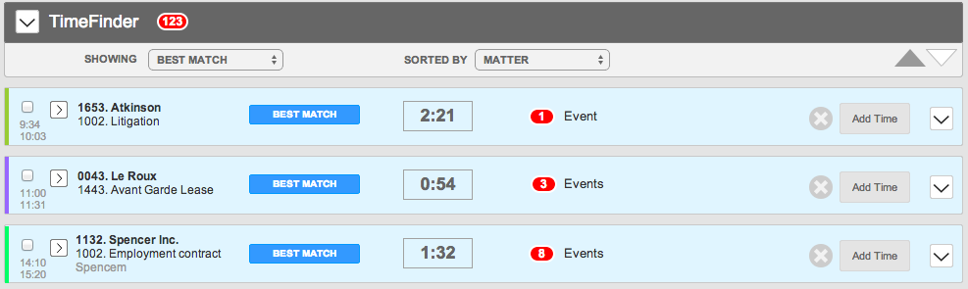
- It is possible to switch the view to see the Timefinder records by ‘EVENT TIME’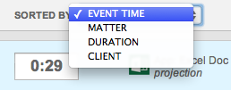
- Additional Time Finder events can be shown by switching the view to ‘ALL’
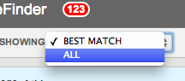

Responsive Framework
This demonstrates how the framework will adapt to Desktop, tablet and mobile screens.

This view in launched by clicking on ‘Responsive Framework’. This part of the prototype is not interactive and only shows the framework.

- Open a large browser window. The desktop view is presented
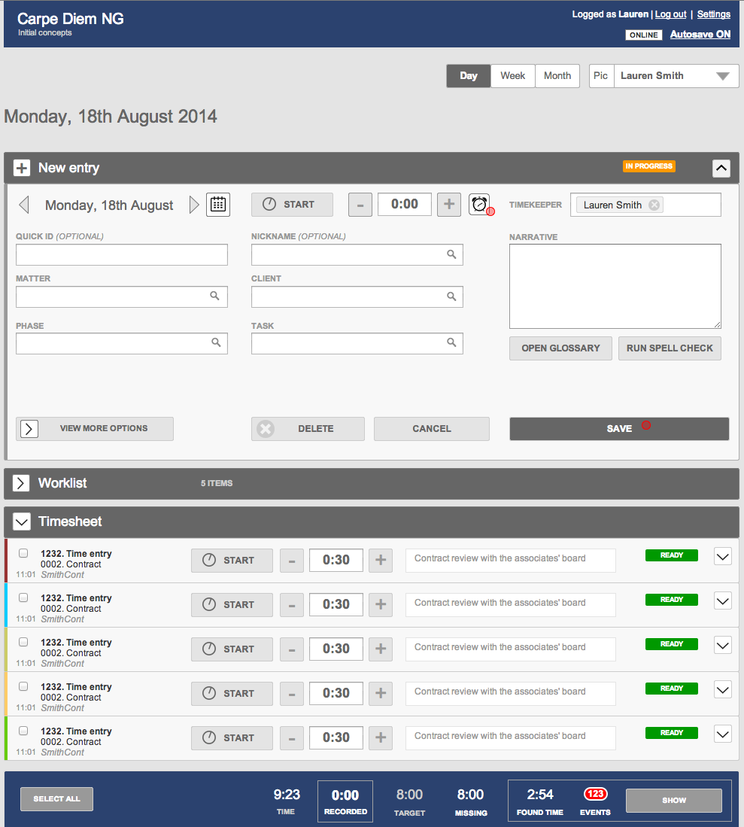
- Reduce the window up to 760 px wide. The Tablet portrait view will be displayed.
Note how the time entry form has reduced and scroll down to see how the Time entries are displayed.
- Reduce to 370 px (the mobile size is 320px wide but the breakpoint has been put to 370 for the demo)

